- Configure IPV6 Addressing

Q.1 Open your Windows or Linux system, use the command line to assign a static IPv6 address to your primary network adapter, and verify the configuration using ipconfig (Windows) or ifconfig/ip (Linux)?

Answer
I opened Windows PowerShell as Administrator and assigned a static IPv6 address to my Wi-Fi adapter. Then I used the ipconfig command to verify the configuration.
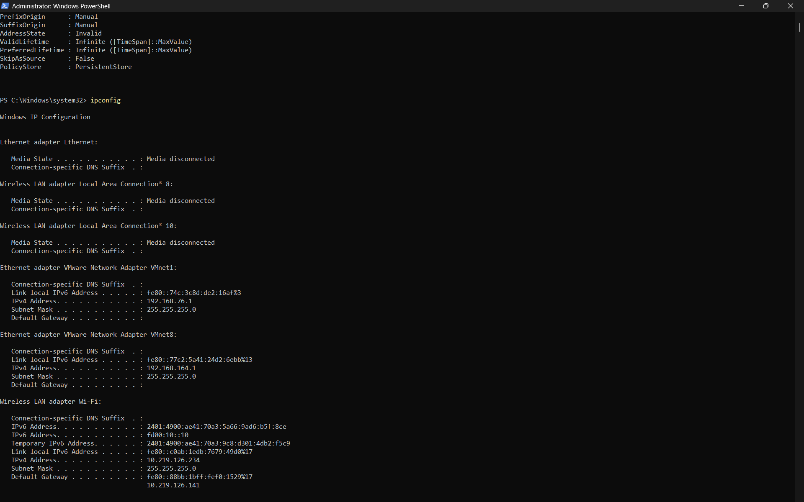

- Command used to assign IPv6 address:
New-NetIPAddress -InterfaceAlias "Wi-Fi" -IPAddress "fd00:10::10" -PrefixLength 64

- Command used to verify:
Ipconfig

- Result: The static IPv6 address fd00:10::10/64 was successfully assigned to the Wi-Fi adapter and verified using ipconfig.

Q.2 Configure a unique local IPv6 address (starting with 'fd') on your system and confirm connectivity by pinging another device on your LAN that also has a unique local IPv6 address.<br><br><em><strong>Hint:</strong> Use the ping6 or ping -6 command for IPv6 testing.</em>?

Answer
- Configuring a Unique Local IPv6 Address

- Device 1 Configuration
IPv6 Address: fd00:10::10/64
Command used:
New-NetIPAddress -InterfaceAlias "Wi-Fi" -IPAddress "fd00:10::10" PrefixLength 64

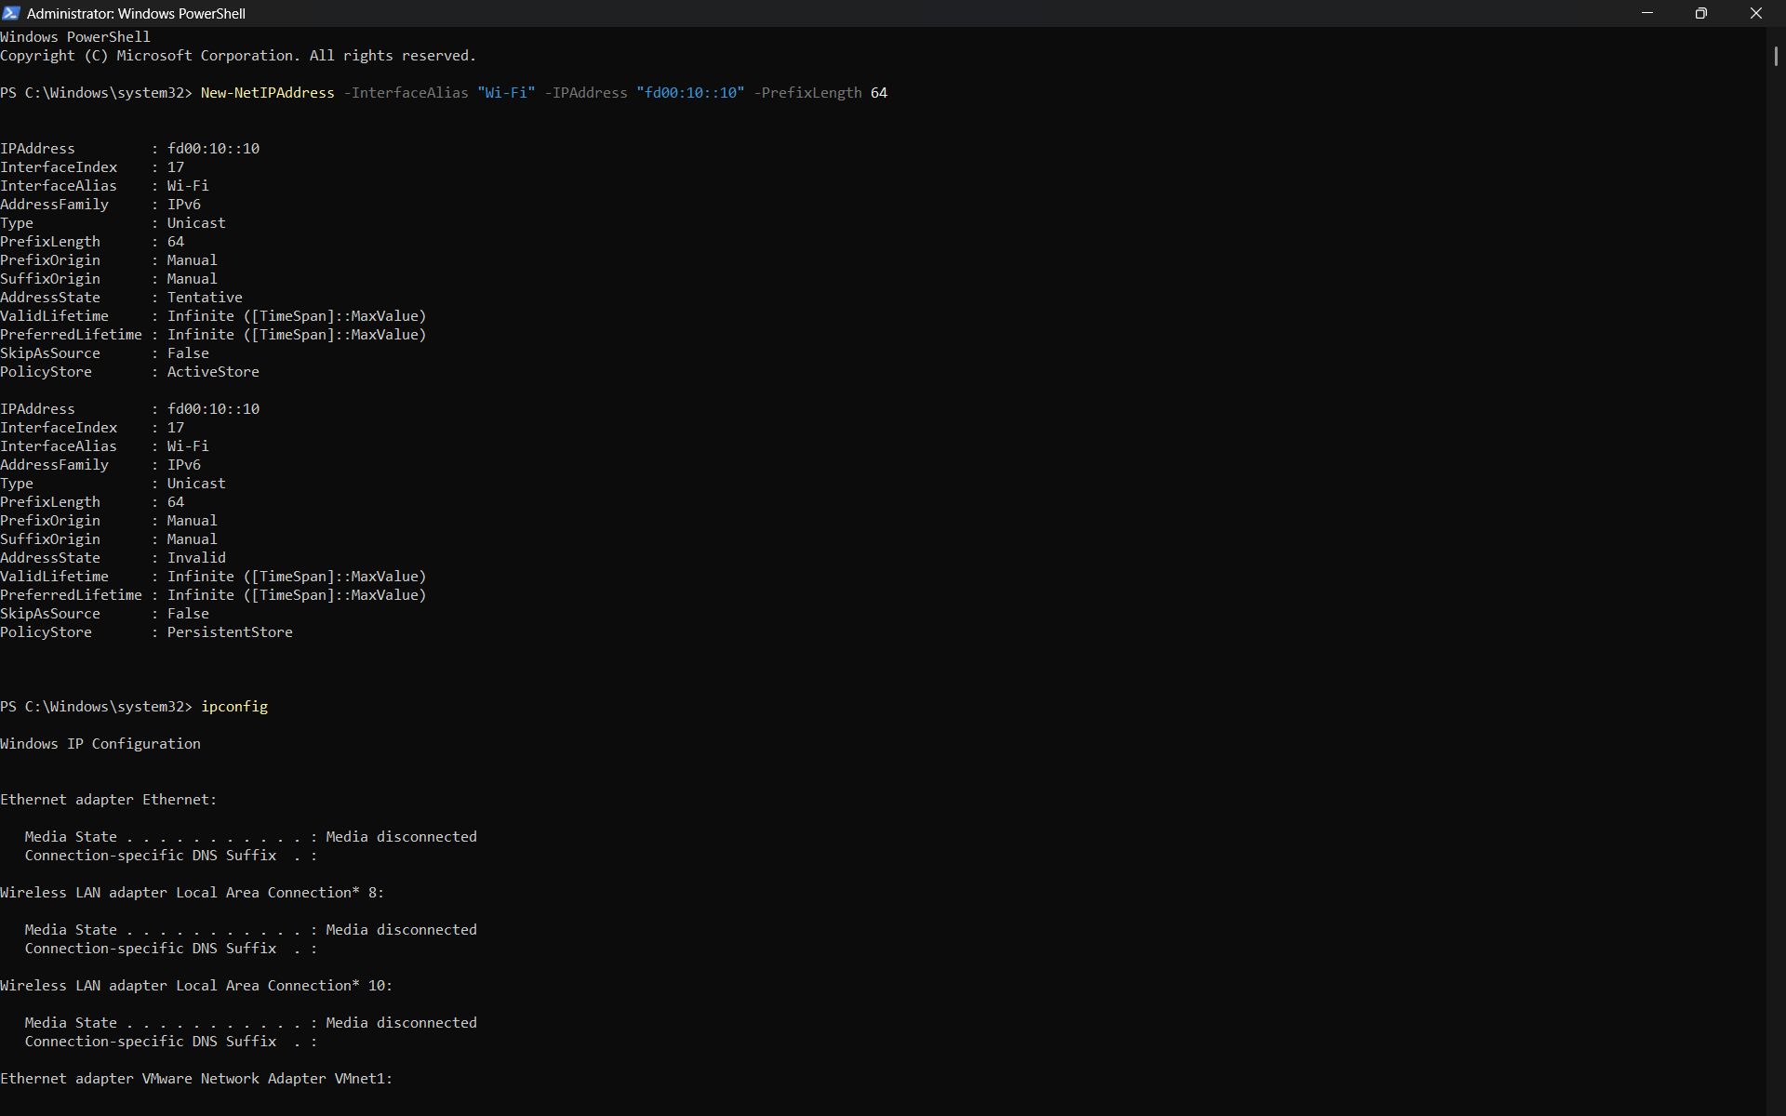
- I verified the IPv6 address using:
ipconfig

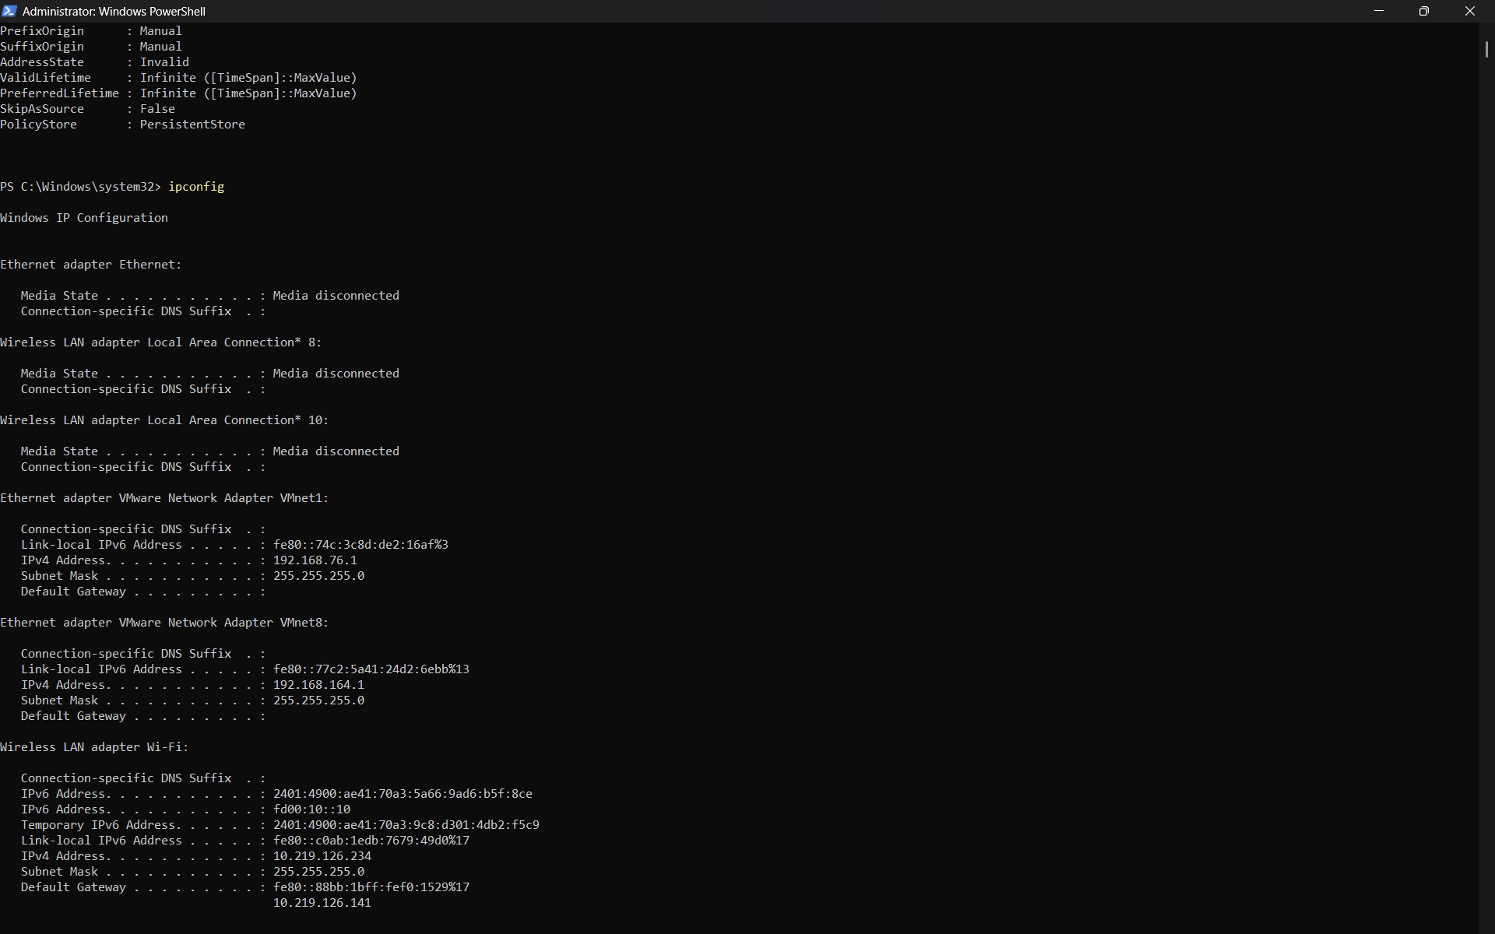

- Device 2 Configuration
IPv6 Address: fd00:10::20/64
Command used:
New-NetIPAddress -InterfaceAlias "Wi-Fi" -IPAddress "fd00:10::20" -PrefixLength 64

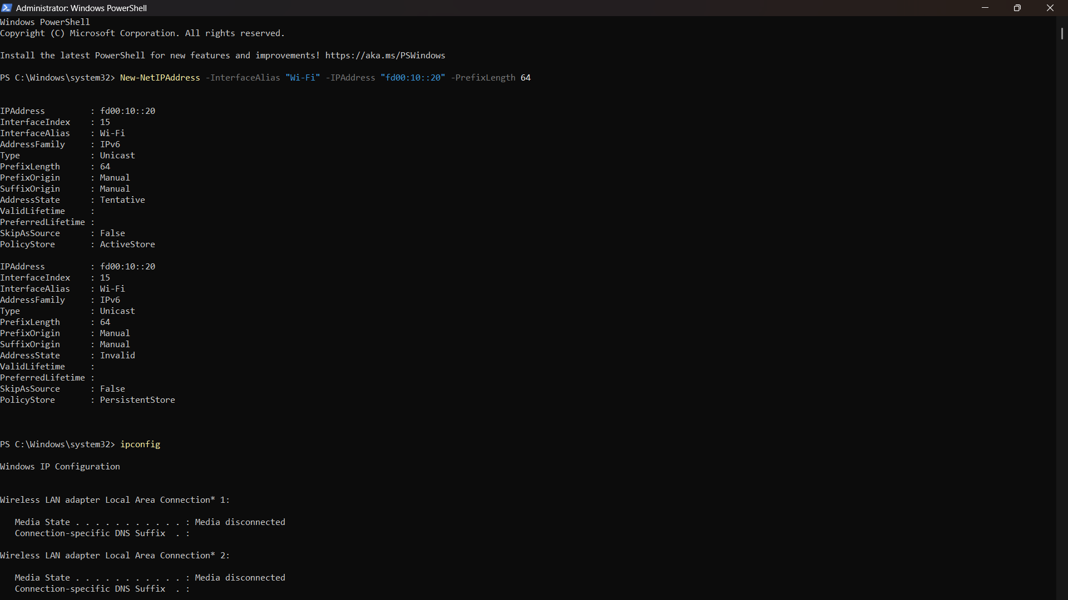

- I verified the IPv6 address using:
Ipconfig

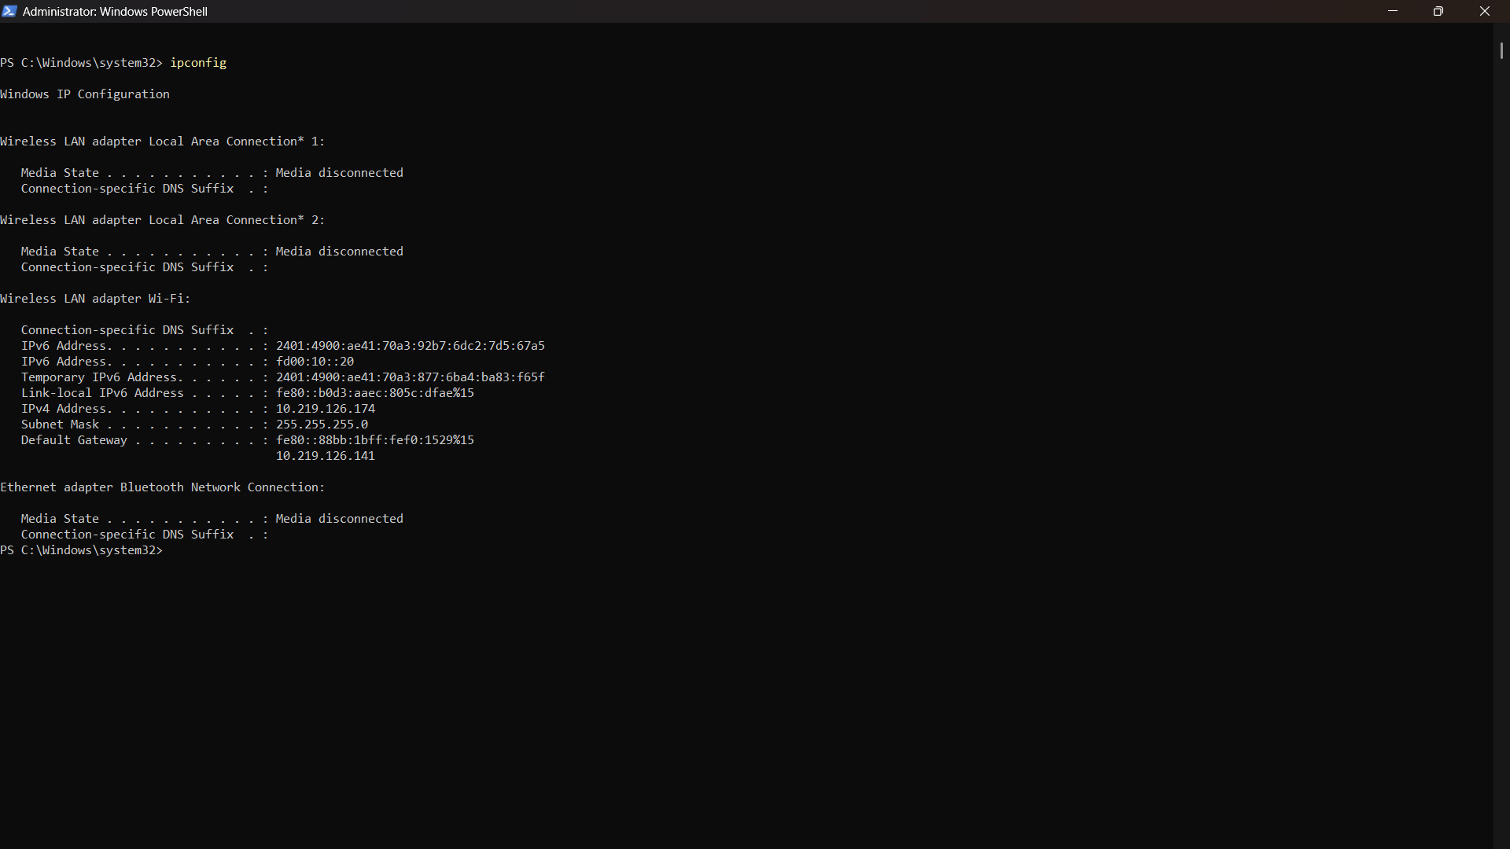
- Connectivity Test
After configuring both devices, I tested the IPv6 connection from Device 1 to Device 2 using:
ping -6 fd00:10::20
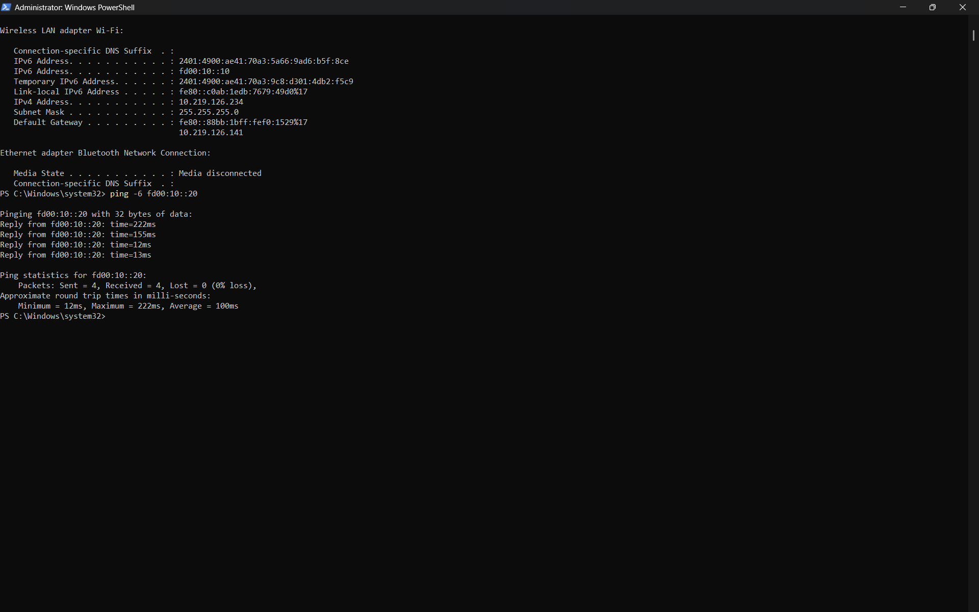

- Result
The ping was successful, which confirmed that both devices could communicate using Unique Local IPv6 addresses on the same LAN.
Device 1: fd00:10::10/64
Device 2: fd00:10::20/64
Therefore, the Unique Local IPv6 configuration and connectivity test were completed successfully.

Q.3 Set up a temporary IPv6 address on your system and check if it changes after a reboot or network disconnect/reconnect.<br><br><em><strong>Constraint:</strong> Document the steps and the observed address behavior in a text file.</em>?

Answer

- Temporary IPv6 Address
- I enabled temporary IPv6 addressing on my Windows system using the following command:
netsh interface ipv6 set privacy state=enabled
- Then I checked the IPv6 configuration using:
ipconfig /all
- Before Network Reconnection

- Temporary IPv6 Address:
2401:4900:ae41:70a3:9c8:d301:4db2:f5c9
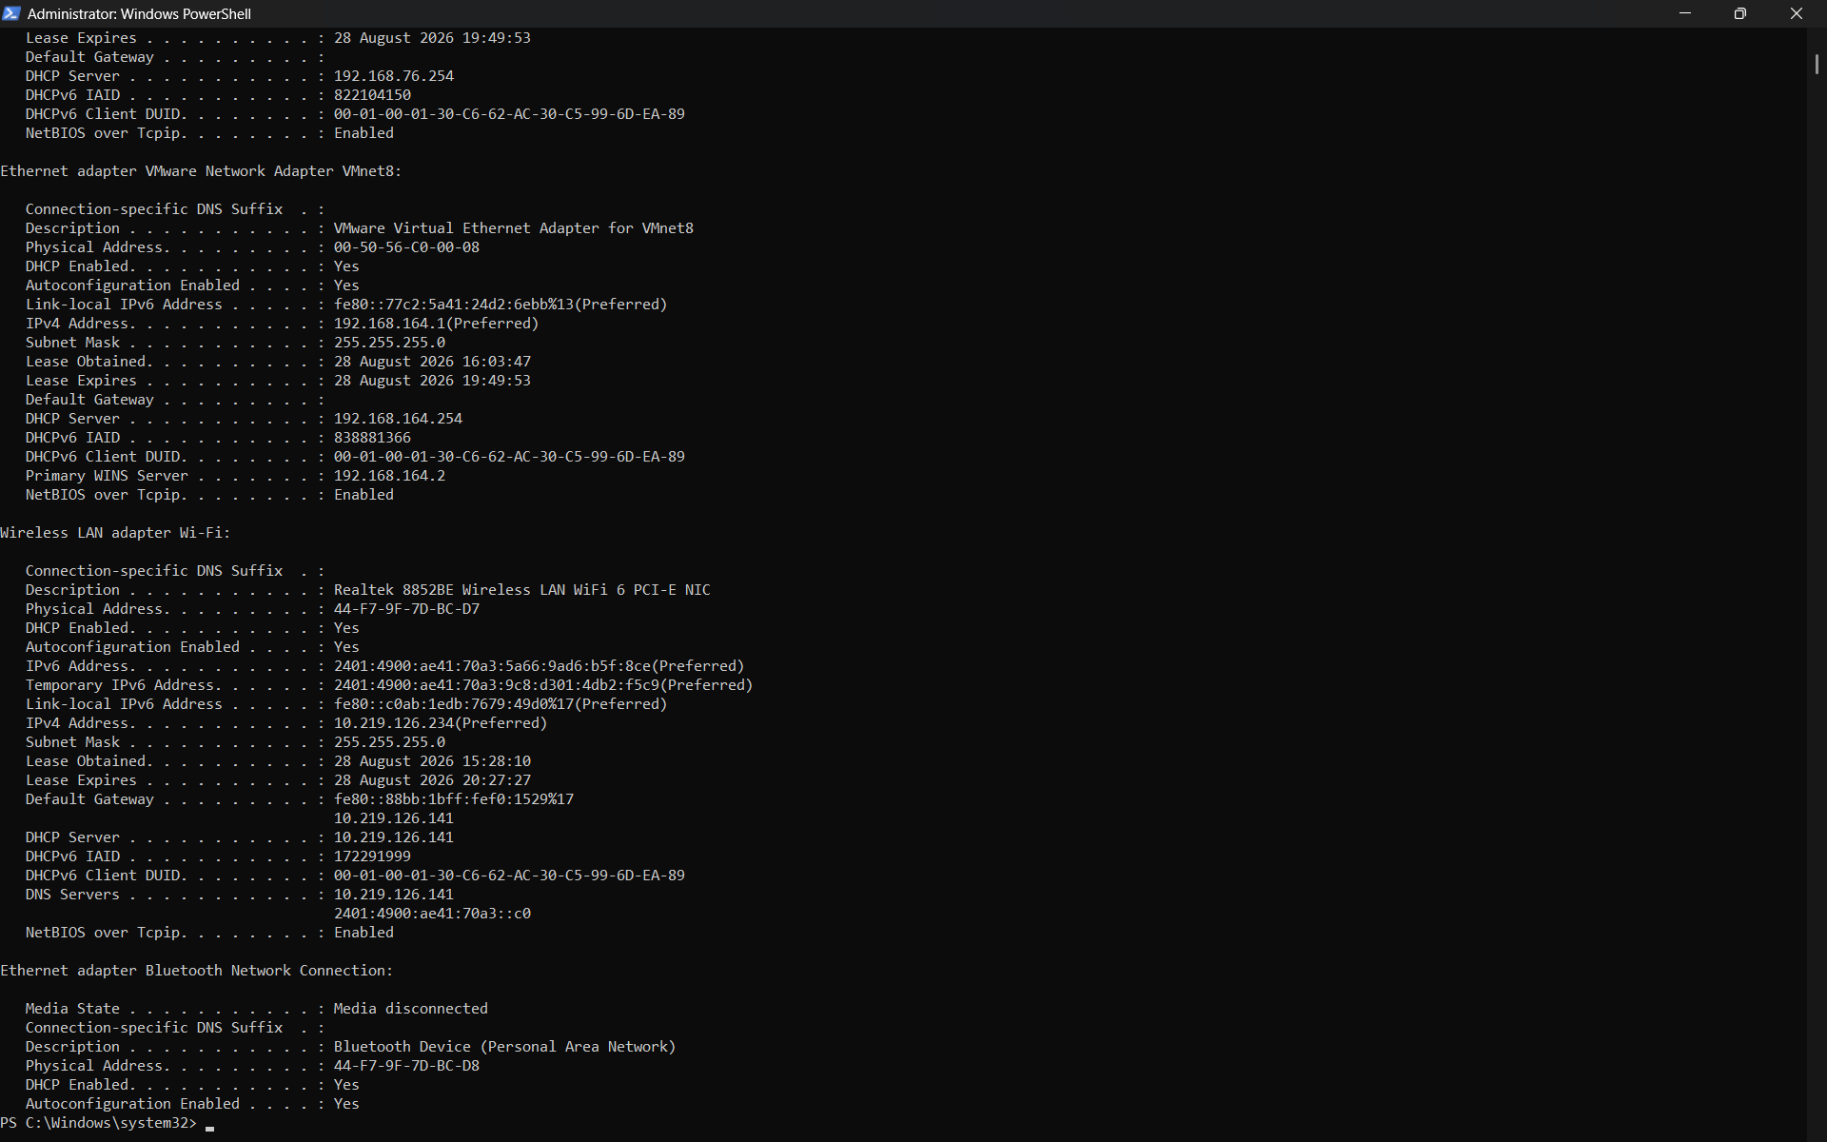

After noting the temporary IPv6 address, I disconnected the Wi-Fi, waited for a few seconds, and then reconnected to the same network.
- I again used:
ipconfig /all
- After Network Reconnection
- Temporary IPv6 Address:
2401:4900:ae41:70a3:9c8:d301:4db2:f5c9
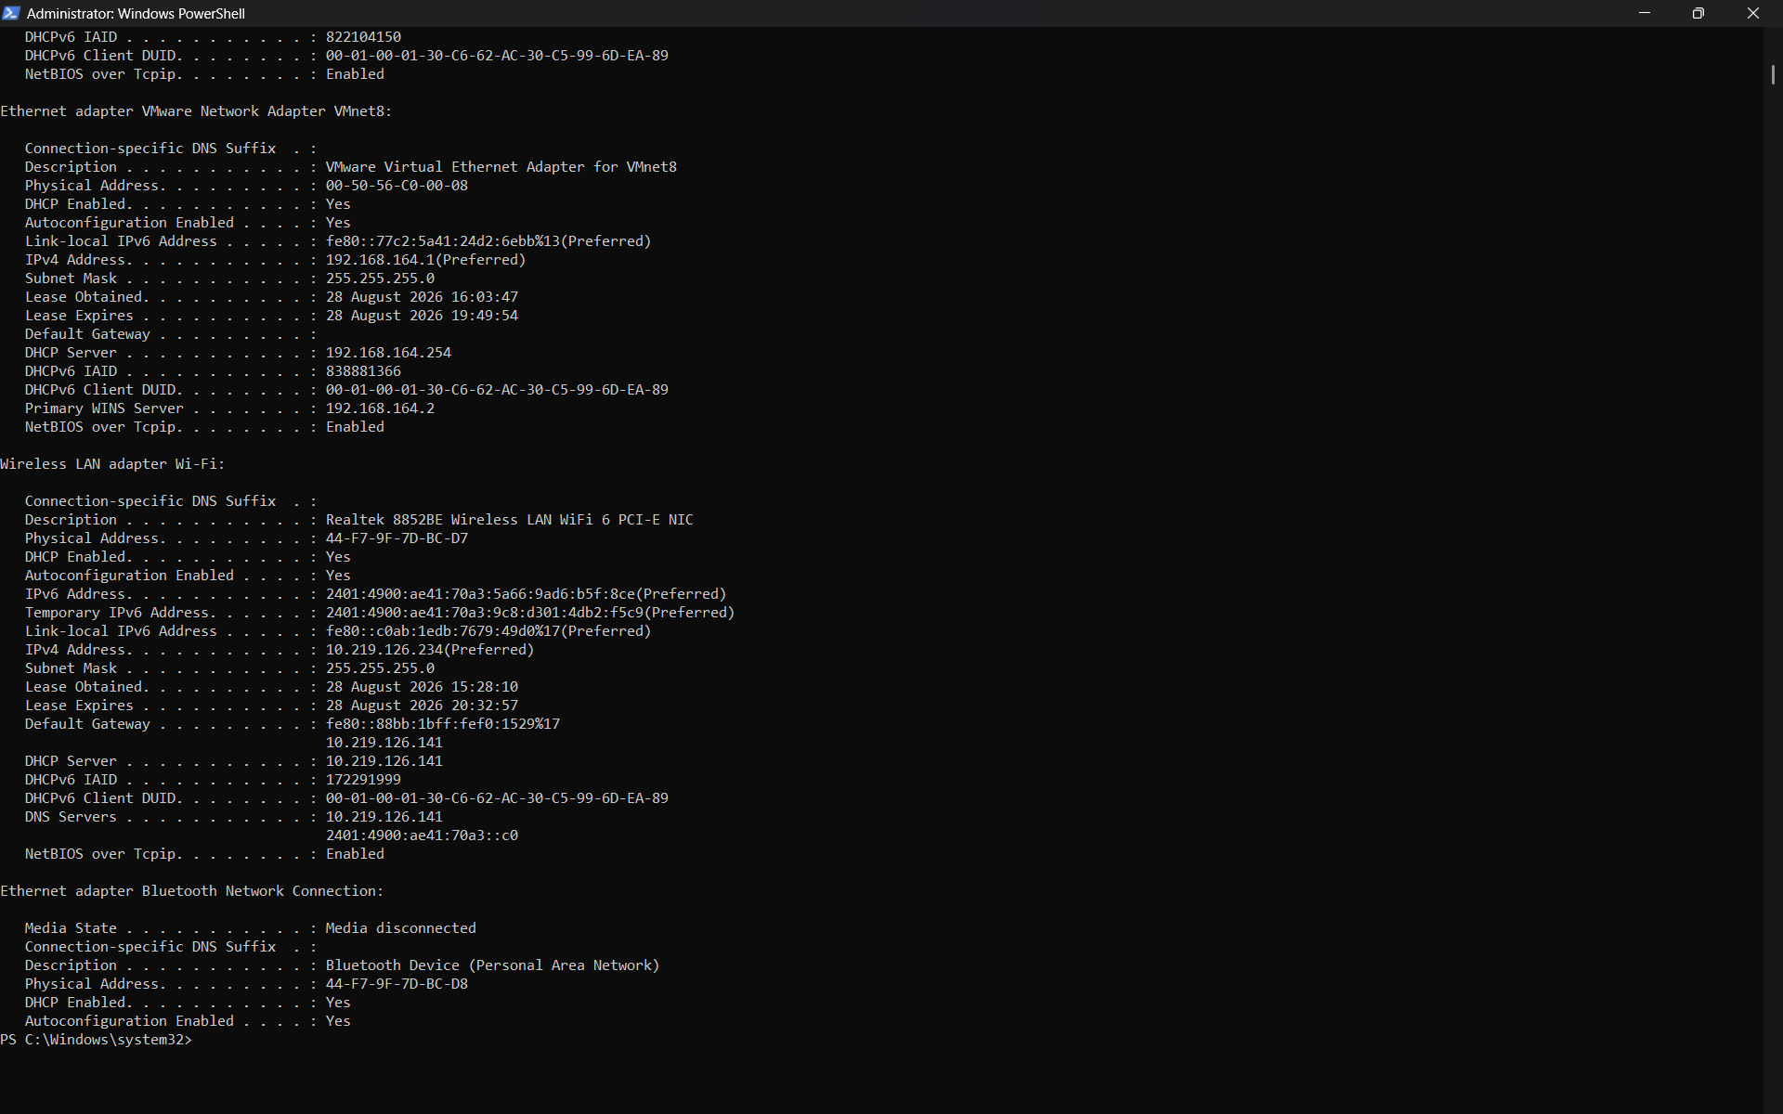

- Observation
The temporary IPv6 address did not change after disconnecting and reconnecting the Wi-Fi.
This shows that a temporary IPv6 address does not necessarily change on every network reconnection. Windows may keep the same temporary address for some time and generate a new one later based on its privacy-address lifetime.
- Result
The temporary IPv6 address was successfully checked before and after reconnecting the network. In this test, the address remained the same.

Q.4 Simulate a Zomato-style search: Write a small script (any language) that stores an array of restaurant names and their IPv6 addresses, then allows the user to input a partial name and returns the matching restaurant's IPv6 address?

Answer
- Zomato-Style Restaurant Search
I created a simple Python program that stores restaurant names along with their IPv6 addresses. The program allows the user to enter a full or partial restaurant name and returns the matching restaurant's IPv6 address.
- Program Code
restaurants = [
("Dominos Pizza", "2001:db8:1::10"),
("Burger King", "2001:db8:1::20"),
("KFC", "2001:db8:1::30"),
("Pizza Hut", "2001:db8:1::40")
]

search = input("Enter restaurant name: ").lower()

found = False

for name, ipv6 in restaurants:
if search in name.lower():
print("Restaurant:", name)
print("IPv6 Address:", ipv6)
found = True

if not found:
print("Restaurant not found")

- Output
I entered the partial restaurant name:
burger
- The program returned:
Restaurant: Burger King
IPv6 Address: 2001:db8:1::20
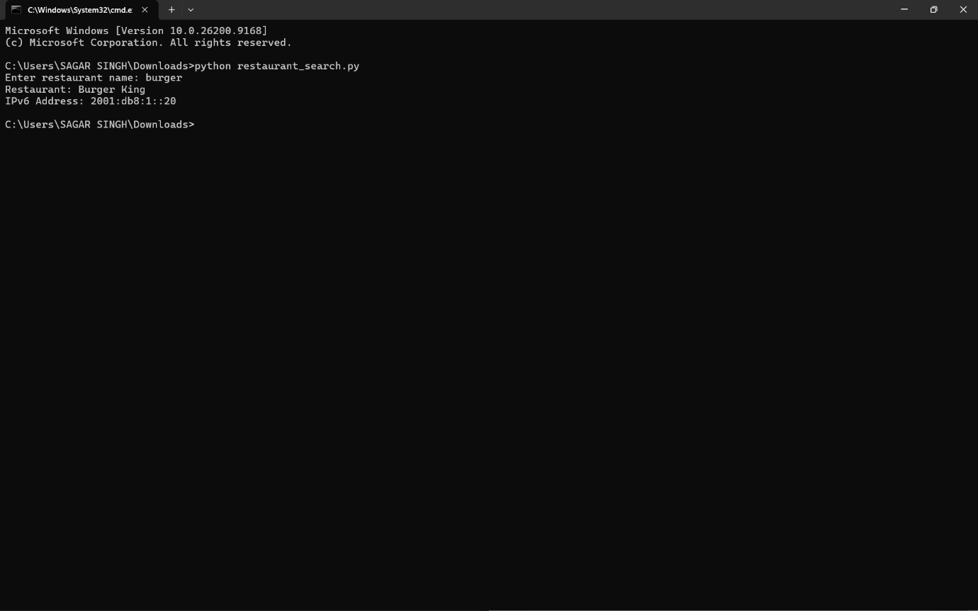
- Result
The program successfully searched for the restaurant using a partial name and displayed the correct IPv6 address.

Q.5 Use ChatGPT or Copilot to generate a sample IPv6 subnetting scenario (with at least 3 subnets), and then manually assign a valid IPv6 address from one of those subnets to your system. Paste the AI-generated scenario and your configuration steps in a text file?

Answer

- IPv6 Subnetting Scenario and Manual Configuration
- AI-Generated IPv6 Subnetting Scenario
A food delivery company has been given the IPv6 network:
fd12:3456:789a::/48
- The company needs three separate subnets:

Department | IPv6 Subnet
- Delivery Partners | fd12:3456:789a:1::/64
- Restaurants | fd12:3456:789a:2::/64
- Admins | fd12:3456:789a:3::/64

I selected the Delivery Partners subnet.
- Selected Subnet:
fd12:3456:789a:1::/64
- IPv6 address assigned to my system:
fd12:3456:789a:1::10/64
- Configuration Steps
I opened Windows PowerShell as Administrator and used the following command:
New-NetIPAddress -InterfaceAlias "Wi-Fi" -IPAddress "fd12:3456:789a:1::10" -PrefixLength 64
- Then I verified the configuration using:
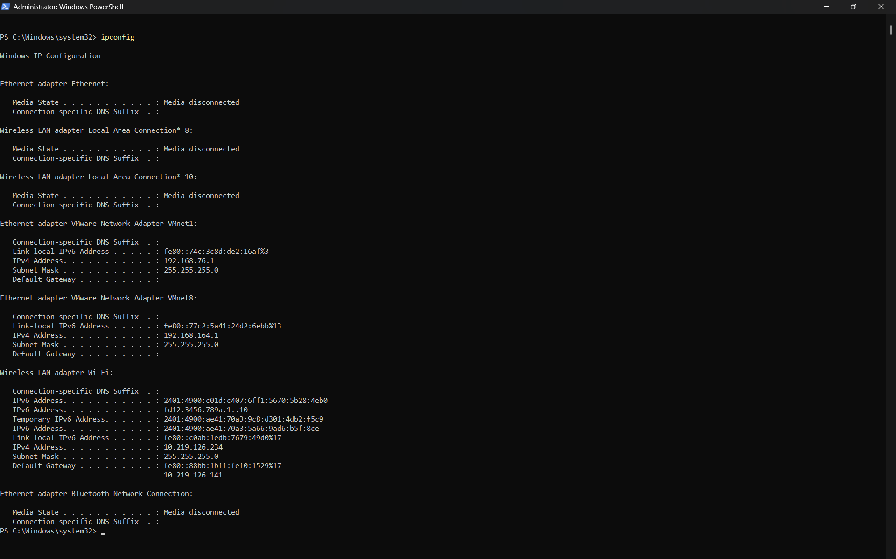
Ipconfig

- Result
The IPv6 address fd12:3456:789a:1::10 appeared under the Wireless LAN adapter Wi-Fi section.
Therefore, a valid IPv6 address from the selected subnet was successfully assigned and verified on my system.

